**Name: Raksha**

**Date: 19/7/25**

**Terraform class 3-tasks- local, random ,null explore**

**Batch 11**

**\*\*\*\*\*\*\*\*\*\*\*\*\*\*\*\*\*\*\*\*\*\*\*\*\*\*\*\*\*\*\*\*\*\*\*\*\*\*\*\*\*\*\*\*\*\*\*\*\*\*\*\*\*\*\*\*\***

**2.explore these providers -> local, random, null**

**Goto registry.terraform.io**

**Local_file -provider**

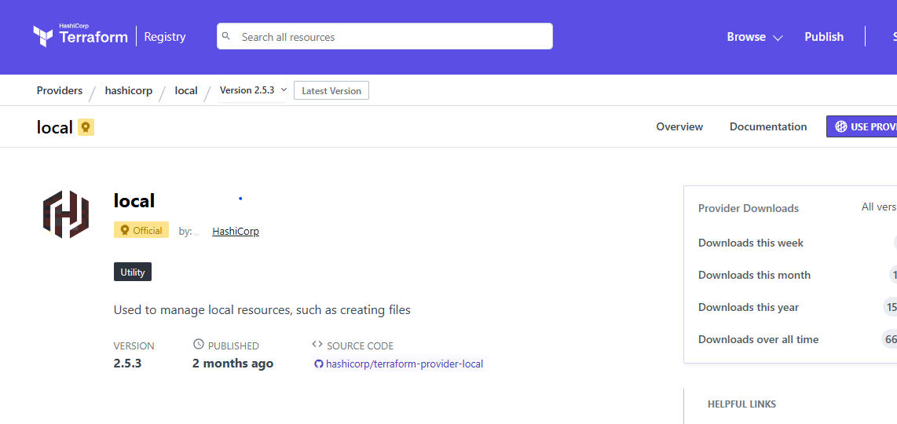

Search local-> go to documentation-> in that we can explore below page

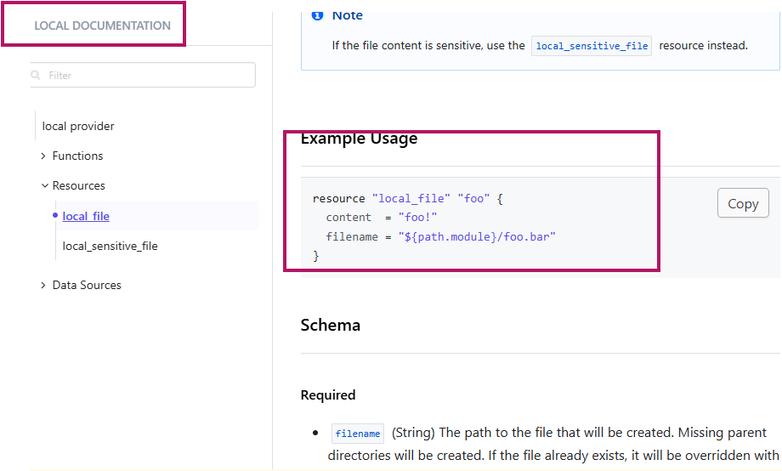

Local_file->provider

resource "local_file" "registry_local" {

content = " this is local registry file"

filename = "registry_local.bar"

}

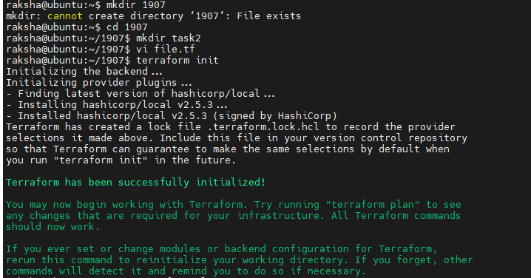

Terraform.plan

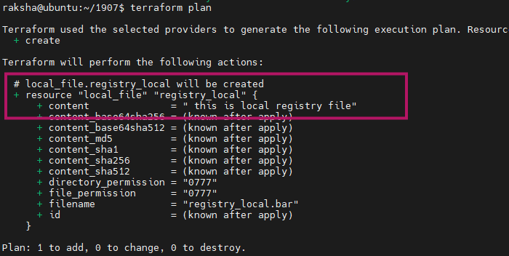

Terraform apply

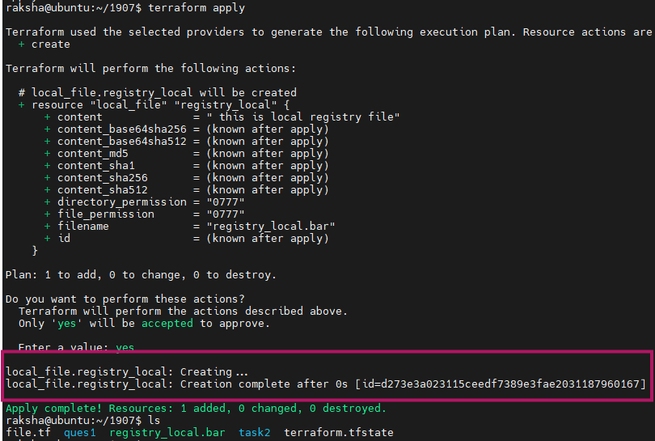

Tree -a

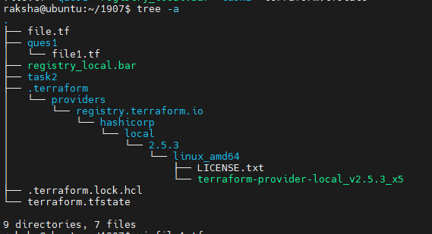

If working with the local_sensitive_file resource -it's part of the **local provider**, similar to local_file, but it treats the content as **sensitive**.

->The file content won’t be printed in the plan/apply output

->It's useful when handling secrets locally (eg :passwords, keys)

Local_sensitive_file-provider

resource "local_sensitive_file" "raksha" {

content = "this is same as local file provider but contains store sensitive data"

filename = "file.txt"

}

Terraform init stage

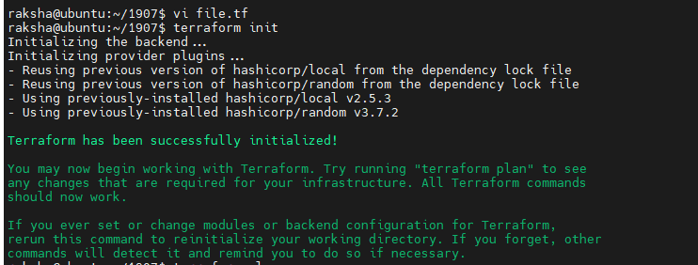

Terraform plan stage

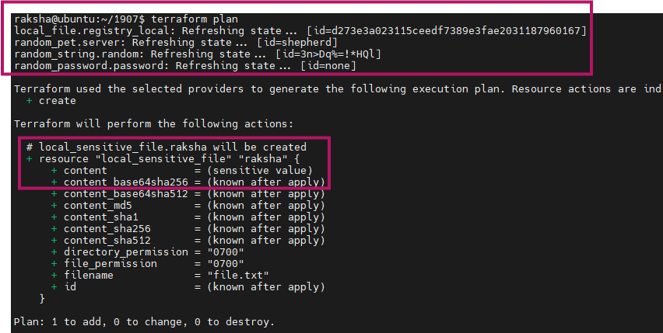

Terraform apply

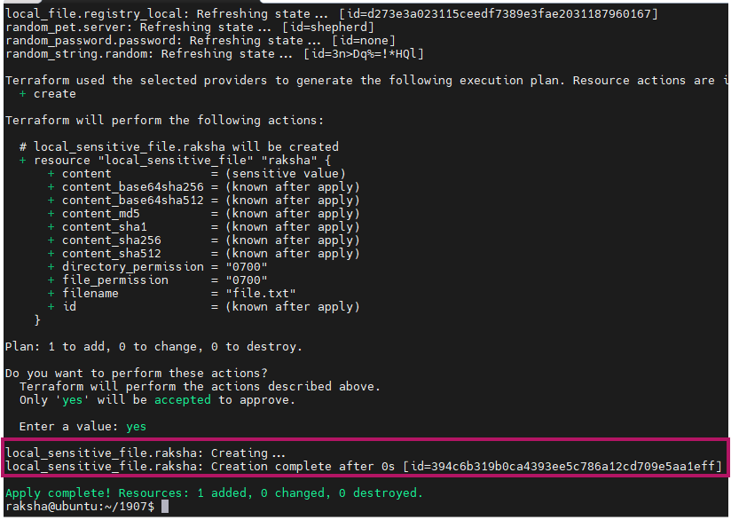

Cat file.txt

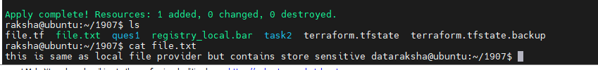

**Random string-provider**

Random string:

resource "random_string" "random" {

length = 12

}

Terraform init -upgrade

Terraform plan

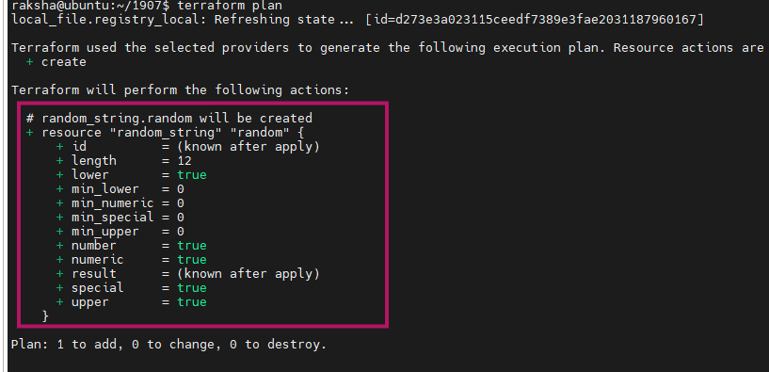

Terraform apply

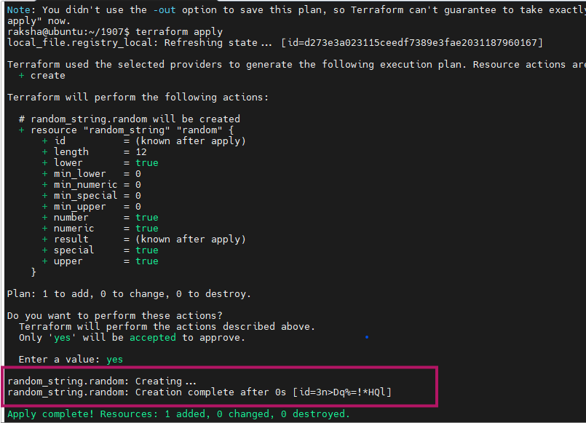

Tree-a

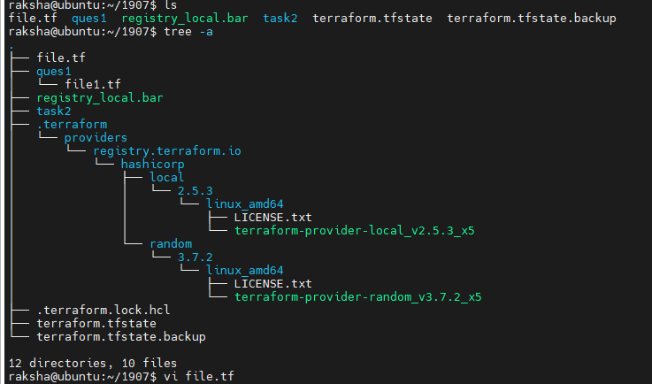

**Random-pet => providers**

variable "ami_id" {

type = string

default = "pet name"

}

resource "random_pet" "server" {

keepers = {

ami_id = var.ami_id

}

length = 2

}

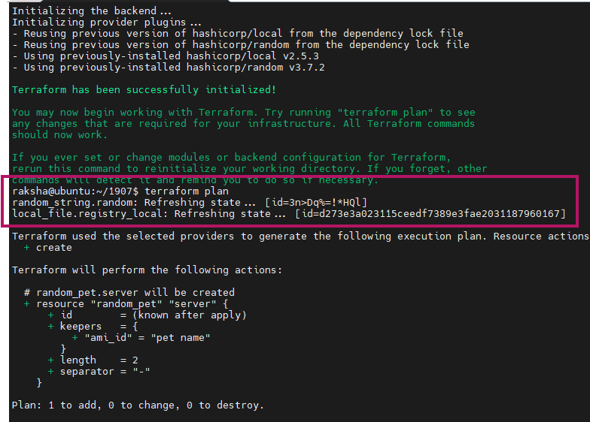

Terraform apply

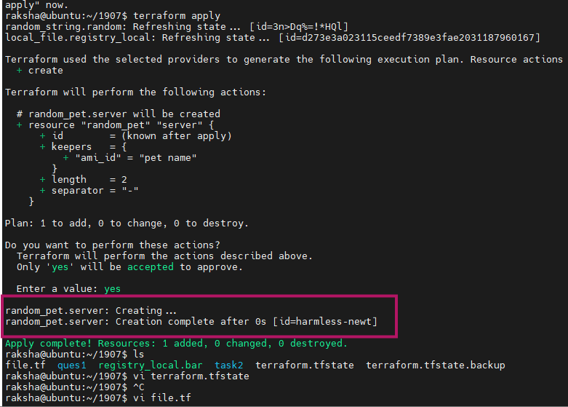

Here changed a value means length to 1

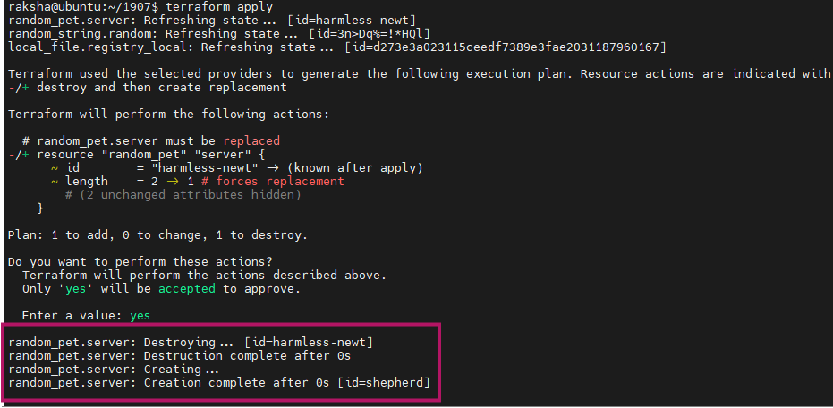

Random password

resource "random_password" "password" {

length = 16

special = true

override_special = "!#$%&*()-_=+[]{}<>:?"

}

Terraform init

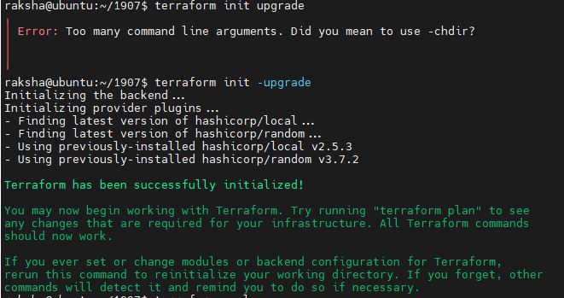

Terraform apply

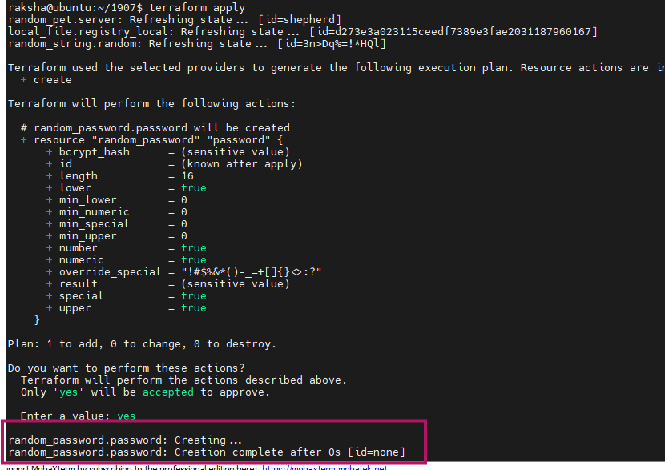

Null-resources-provider

resource "null_resource" "create_folder" {

provisioner "local-exec" {

command = "mkdir -p ./resource2_raksha"

}

}

Alias t = ‘terraform’

t init

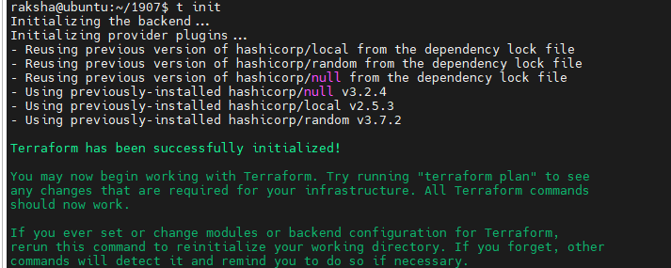

T plan and t apply

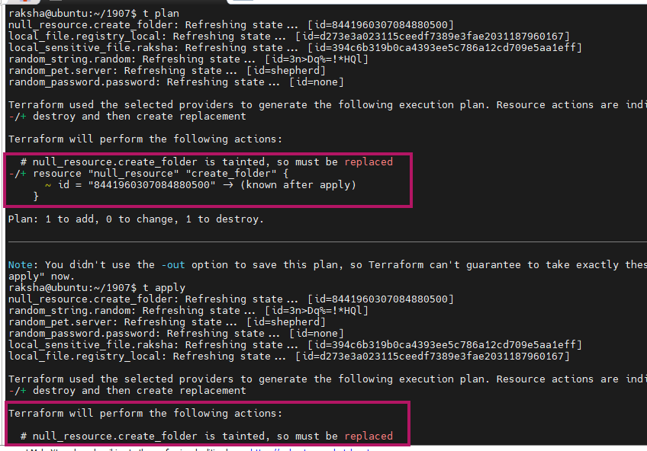

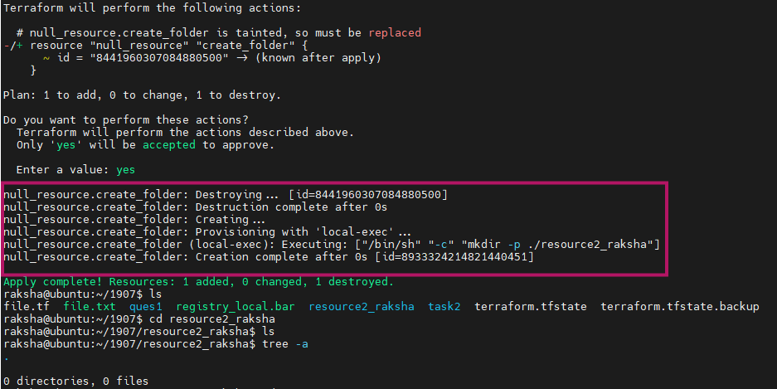

Tree -a

